Experiment Number : 4

Problem Statement: **Write a python code to implement Decision tree and random forest classifier for a suitable use case.**

NAME: Harshwardhan PatilROLLNO: 50

CLASS: IT-B BATCH: B1

DATE OF PERFORMANCE: 11-02-2025

CODE:

import pandas as pd

import numpy as np

import matplotlib.pyplot as plt

from sklearn.tree import DecisionTreeClassifier, plot_tree

from sklearn.model_selection import train_test_split

from sklearn.metrics import accuracy_score

url = "https://raw.githubusercontent.com/datasciencedojo/datasets/master/titanic.csv"

data = pd.read_csv(url)

# Preprocess the dataset

# Select relevant columns for simplicity (including the target column 'Survived')

data = data[['Pclass', 'Sex', 'Age', 'SibSp', 'Parch', 'Fare', 'Survived']]

# Handle missing data

data['Age'] = data['Age'].fillna(data['Age'].median())  # Fill missing Age with median

data.dropna(subset=['Survived', 'Sex'], inplace=True)    # Drop rows where 'Survived' or 'Sex' is missing

# Convert categorical variables to numerical values

data['Sex'] = data['Sex'].map({'male': 0, 'female': 1})

# Define features and target variable

X = data[['Pclass', 'Sex', 'Age', 'SibSp', 'Parch', 'Fare']]

y = data['Survived']

# Train a Decision Tree Classifier to calculate Gini and Information Gain

# Split data into training and testing sets

X_train, X_test, y_train, y_test = train_test_split(X, y, test_size=0.3, random_state=42)

# Initialize and train the Decision Tree model

clf = DecisionTreeClassifier(criterion='gini', max_depth=5)

clf.fit(X_train, y_train)

# Predict using the trained model

y_pred = clf.predict(X_test)

# Calculate accuracy

accuracy = accuracy_score(y_test, y_pred)

print(f'Accuracy of the Decision Tree: {accuracy * 100:.2f}%')

# Visualize the decision tree

plt.figure(figsize=(12,8))

plot_tree(clf, filled=True, feature_names=X.columns, class_names=['Not Survived', 'Survived'], rounded=True)

plt.title("Decision Tree for Titanic Survival Prediction")

plt.show()

# Calculate Gini Index and Information Gain for a sample split

# Function to calculate Gini index for a dataset

def gini_index(data):

    total = len(data)

    if total == 0:

        return 0

    # Count the occurrences of each class in the target variable

    class_counts = data['Survived'].value_counts()

    gini = 1 - sum((class_counts / total) ** 2)

    return gini

# Function to calculate Information Gain for a feature

def information_gain(data, feature):

    total_gini = gini_index(data)  # Gini index of the dataset before the split

    values = data[feature].unique()

    weighted_gini = 0

    # For each value of the feature, calculate the weighted Gini index

    for value in values:

        subset = data[data[feature] == value]

        subset_gini = gini_index(subset)

        weighted_gini += (len(subset) / len(data)) * subset_gini

    # Information Gain is the reduction in Gini index after the split

    return total_gini - weighted_gini

# Example: Calculate Gini index and Information Gain for the feature 'Pclass'

print("\nCalculating Gini index and Information Gain for the feature 'Pclass':")

gini_before_split = gini_index(data)

info_gain_pclass = information_gain(data, 'Pclass')

print(f"Gini index before the split: {gini_before_split:.4f}")

print(f"Information Gain for 'Pclass': {info_gain_pclass:.4f}")

OUTPUT:

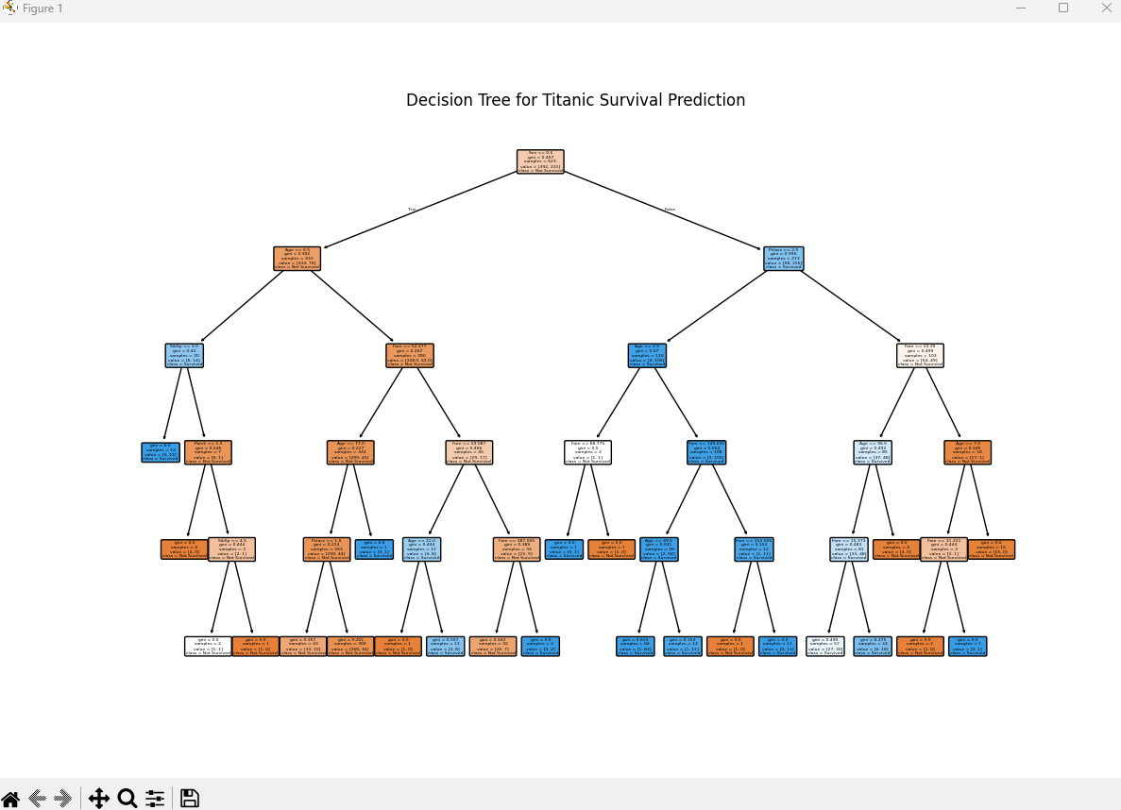

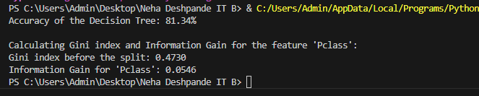

Conclusion: **We have wrote a Python Code to design Decision Tree for the given dataset. Calculate Gini index and Information Gain.  
  
  
Random Forest:**  
PROGARM:

import pandas as pd

import numpy as np

import matplotlib.pyplot as plt

import seaborn as sns

from sklearn.model_selection import train_test_split

from sklearn.preprocessing import LabelEncoder

from sklearn.ensemble import RandomForestClassifier

from sklearn.metrics import accuracy_score, classification_report, confusion_matrix

from sklearn.tree import plot_tree

# Load dataset from CSV

column_names = ["buying", "maint", "doors", "persons", "lug_boot", "safety", "unacc"]

df = pd.read_csv("car_evaluation.csv", names=column_names, header=None)

# Strip spaces from column names to avoid errors

df.columns = df.columns.str.strip()

# Verify available columns

print("Available columns:", df.columns)

# Check if 'class' column exists

target_col = "unacc"

if target_col not in df.columns:

    raise KeyError(f"Error: Column '{target_col}' not found in dataset. Available columns: {df.columns}")

# Encode categorical data

label_encoders = {}

for col in df.columns:

    le = LabelEncoder()

    df[col] = le.fit_transform(df[col])

    label_encoders[col] = le

# Split data into features and target

X = df.drop(columns=[target_col])

y = df[target_col]

# Split dataset into training and testing sets

X_train, X_test, y_train, y_test = train_test_split(X, y, test_size=0.2, random_state=42)

# Train Random Forest classifier

clf = RandomForestClassifier(n_estimators=100, random_state=42)

clf.fit(X_train, y_train)

# Make predictions

y_pred = clf.predict(X_test)

# Evaluate model

accuracy = accuracy_score(y_test, y_pred)

report = classification_report(y_test, y_pred)

conf_matrix = confusion_matrix(y_test, y_pred)

print(f"Accuracy: {accuracy:.4f}")

print("Classification Report:\n", report)

print("Confusion Matrix:\n", conf_matrix)

# Visualize one of the trees

plt.figure(figsize=(20,10))

plot_tree(clf.estimators_[0], feature_names=X.columns, class_names=label_encoders[target_col].classes_, filled=True, rounded=True)

plt.show()

# Plot confusion matrix

plt.figure(figsize=(8,6))

sns.heatmap(conf_matrix, annot=True, fmt="d", cmap="Blues", xticklabels=label_encoders[target_col].classes_, yticklabels=label_encoders[target_col].classes_)

plt.xlabel("Predicted")

plt.ylabel("Actual")

plt.title("Confusion Matrix")

plt.show()

Output :

